Week-2
Exercise1:
Aim:
To develop a basic Spring application using XML configuration and create beans for the Library Management system.
1. pom.xml
<project xmlns="http://maven.apache.org/POM/4.0.0"
xmlns:xsi="http://www.w3.org/2001/XMLSchema-instance"
xsi:schemaLocation="http://maven.apache.org/POM/4.0.0
https://maven.apache.org/xsd/maven-4.0.0.xsd">
<modelVersion>4.0.0</modelVersion>
<groupId>com.library</groupId>
<artifactId>LibraryManagement</artifactId>
<version>0.0.1-SNAPSHOT</version>
<dependencies>
<!-- Spring Context -->
<dependency>
<groupId>org.springframework</groupId>
<artifactId>spring-context</artifactId>
<version>5.3.39</version>
</dependency>
</dependencies>
</project>
2. applicationContext.xml
<?xml version="1.0" encoding="UTF-8"?>
<beans xmlns="http://www.springframework.org/schema/beans"
xmlns:xsi="http://www.w3.org/2001/XMLSchema-instance"
xsi:schemaLocation="
http://www.springframework.org/schema/beans
https://www.springframework.org/schema/beans/spring-beans.xsd">
<!-- BookRepository Bean -->
<bean id="bookRepository"
class="com.library.repository.BookRepository"/>
<!-- BookService Bean -->
<bean id="bookService"
class="com.library.service.BookService">
<!-- Seter Injection -->
<property name="bookRepository"
ref="bookRepository"/>
</bean>
</beans>

3. BookRepository.java
package com.library.repository;
public class BookRepository {
public BookRepository() {
System.out.println("BookRepository object created");
}
public void displayRepository() {
System.out.println("Book Repository Method Called");
}
}
4. BookService.java
package com.library.service;
import com.library.repository.BookRepository;
public class BookService {
private BookRepository bookRepository;
public BookService() {
System.out.println("BookService object created");
}
public void setBookRepository(BookRepository bookRepository) {
this.bookRepository = bookRepository
}
public void displayService() {
System.out.println("Book Service Method Called");
bookRepository.displayRepository();
}
}

5. MainApp.java
package com.library;
import org.springframework.context.ApplicationContext;
import org.springframework.context.support.ClassPathXmlApplicationContext;
import com.library.service.BookService;
public class MainApp {
public static void main(String[] args) {
ApplicationContext context =
new ClassPathXmlApplicationContext("applicationContext.xml");
BookService service =
context.getBean("bookService", BookService.class);
service.displayService();
}
}

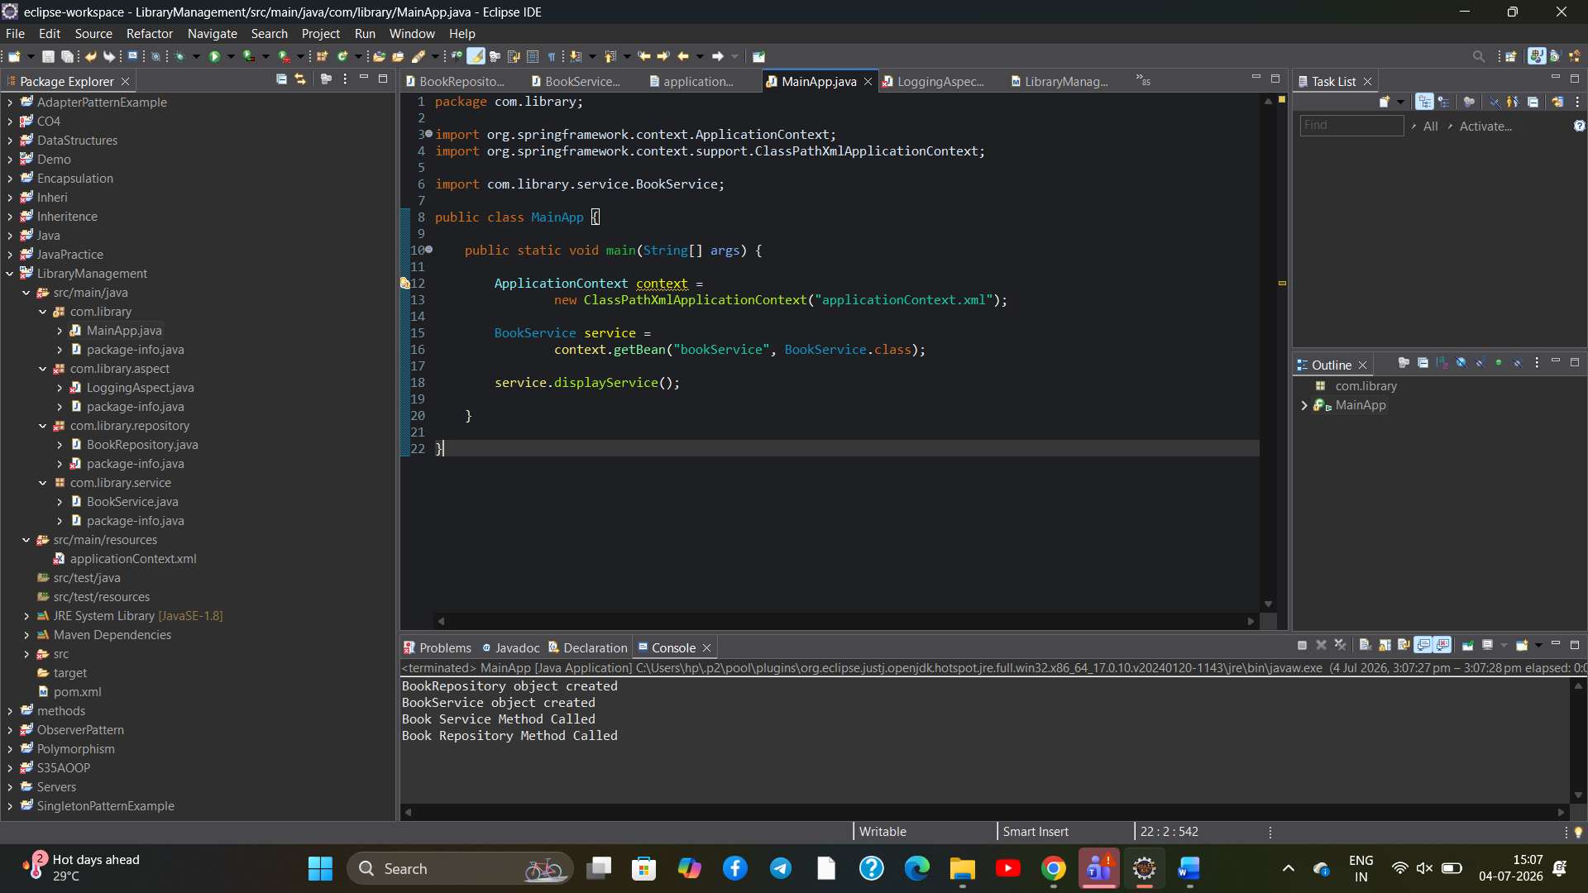
Conclusion :
- Successfully configured a basic Spring application.
- Created and configured beans using XML.
- Loaded the Spring application context successfully.
- Verified the application by executing the BookService method.
Exercise 2: Implementing Dependency Injection
Aim
To implement Dependency Injection (DI) using Setter Injection in the Spring Framework for the Library Management application.
Code
Same code as Exercise 1.
Output(same as ex1):


Difference from Exercise 1:
- Focus is on Setter Dependency Injection.
- BookRepository is injected into BookService.
- Spring performs Dependency Injection automatically.
Conclusion:
- Successfully implemented Dependency Injection using Setter Injection.
- Injected the BookRepository object into the BookService class.
- Verified dependency injection using the Spring Framework.
- Successfully executed the application.

Exercise 5: Configuring the Spring IoC Container
Aim:
To configure the Spring IoC Container for creating, managing, and injecting beans in the Library Management application.
Code
Same code as Exercise 2.
Output:


Difference from Exercise 2:
- Focus is on the Spring IoC Container.
- Spring creates and manages beans.
- Beans are retrieved using getBean().
Conclusion:
- Successfully configured the Spring IoC Container.
- Created and managed beans using XML configuration.
- Verified bean creation and dependency management.
- Successfully executed the application.

Exercise 3
Aim:
To implement logging in a Spring application using Spring AOP and measure the execution time of methods.
1. pom.xml:
<project xmlns="http://maven.apache.org/POM/4.0.0"
xmlns:xsi="http://www.w3.org/2001/XMLSchema-instance"
xsi:schemaLocation="http://maven.apache.org/POM/4.0.0
https://maven.apache.org/xsd/maven-4.0.0.xsd">
<modelVersion>4.0.0</modelVersion>
<groupId>com.library</groupId>
<artifactId>LibraryManagement</artifactId>
<version>0.0.1-SNAPSHOT</version>
<dependencies>
<!-- Spring Context -->
<dependency>
<groupId>org.springframework</groupId>
<artifactId>spring-context</artifactId>
<version>5.3.39</version>
</dependency>
<!-- Spring AOP -->
<dependency>
<groupId>org.springframework</groupId>
<artifactId>spring-aop</artifactId>
<version>5.3.39</version>
</dependency>
<!-- AspectJ Weaver -->
<dependency>
<groupId>org.aspectj</groupId>
<artifactId>aspectjweaver</artifactId>
<version>1.9.22.1</version>
</dependency>
</dependencies>
</project>
2. applicationContext.xml
<?xml version="1.0" encoding="UTF-8"?>
<beans xmlns="http://www.springframework.org/schema/beans"
xmlns:aop="http://www.springframework.org/schema/aop"
xmlns:xsi="http://www.w3.org/2001/XMLSchema-instance"
xsi:schemaLocation="
http://www.springframework.org/schema/beans
https://www.springframework.org/schema/beans/spring-beans.xsd
http://www.springframework.org/schema/aop
https://www.springframework.org/schema/aop/spring-aop.xsd">
<bean id="bookRepository"
class="com.library.repository.BookRepository"/>
<bean id="bookService"
class="com.library.service.BookService">
<property name="bookRepository"
ref="bookRepository"/>
</bean>
<bean id="loggingAspect"
class="com.library.aspect.LoggingAspect"/>
<aop:aspectj-autoproxy/>
</beans>
3. BookRepository.java
package com.library.repository;
public class BookRepository {
public BookRepository() {
System.out.println("BookRepository object created");
}
public void displayRepository() {
System.out.println("Book Repository Method Called");
}
}
4. BookService.java
package com.library.service;
import com.library.repository.BookRepository;
public class BookService {
private BookRepository bookRepository;
public BookService() {
System.out.println("BookService object created");
}
public void setBookRepository(BookRepository bookRepository) {
this.bookRepository = bookRepository;
}
public void displayService() {
System.out.println("Book Service Method Called");
bookRepository.displayRepository();
}
}
5. LoggingAspect.java (Exercise 3)
package com.library.aspect;
import org.aspectj.lang.ProceedingJoinPoint;
import org.aspectj.lang.annotation.Around;
import org.aspectj.lang.annotation.Aspect;
@Aspect
public class LoggingAspect {
@Around("execution(* com.library.service.BookService.*(..))")
public Object logExecutionTime(ProceedingJoinPoint joinPoint) throws Throwable {
long start = System.currentTimeMillis();
Object result = joinPoint.proceed();
long end = System.currentTimeMillis();
System.out.println(joinPoint.getSignature().getName()
+ " executed in "
+ (end - start)
+ " ms");
return result;
}
}
6. MainApp.java
package com.library;
import org.springframework.context.ApplicationContext;
import org.springframework.context.support.ClassPathXmlApplicationContext;
import com.library.service.BookService;
public class MainApp {
public static void main(String[] args) {
ApplicationContext context =
new ClassPathXmlApplicationContext("applicationContext.xml");
BookService service =
context.getBean("bookService", BookService.class);
service.displayService();
}
}
OUTPUT:
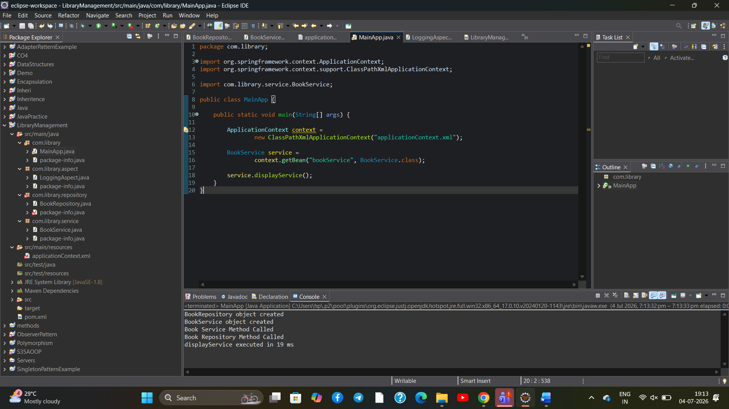
Conclusion:
- Successfully implemented logging using Spring AOP.
- Used @Around advice to measure method execution time.
- Verified that logging was performed without modifying the business logic.
- Successfully executed and tested the application.

Exercise 8: Implementing Basic AOP with Spring
Aim:
To implement basic Aspect-Oriented Programming (AOP) using Spring Framework for logging before and after method execution.
Code:
The codes are the same as Exercise 3:
- pom.xml
- applicationContext.xml
- BookRepository.java
- BookService.java
- MainApp.java

Only LoggingAspect.java is changed :
package com.library.aspect;
import org.aspectj.lang.annotation.After;
import org.aspectj.lang.annotation.Aspect;
import org.aspectj.lang.annotation.Before;
@Aspect
public class LoggingAspect {
@Before("execution(* com.library.service.BookService.*(..))")
public void beforeMethod() {
System.out.println("Before Method Execution");
}
@After("execution(* com.library.service.BookService.*(..))")
public void afterMethod() {
System.out.println("After Method Execution");
}
}
Output:
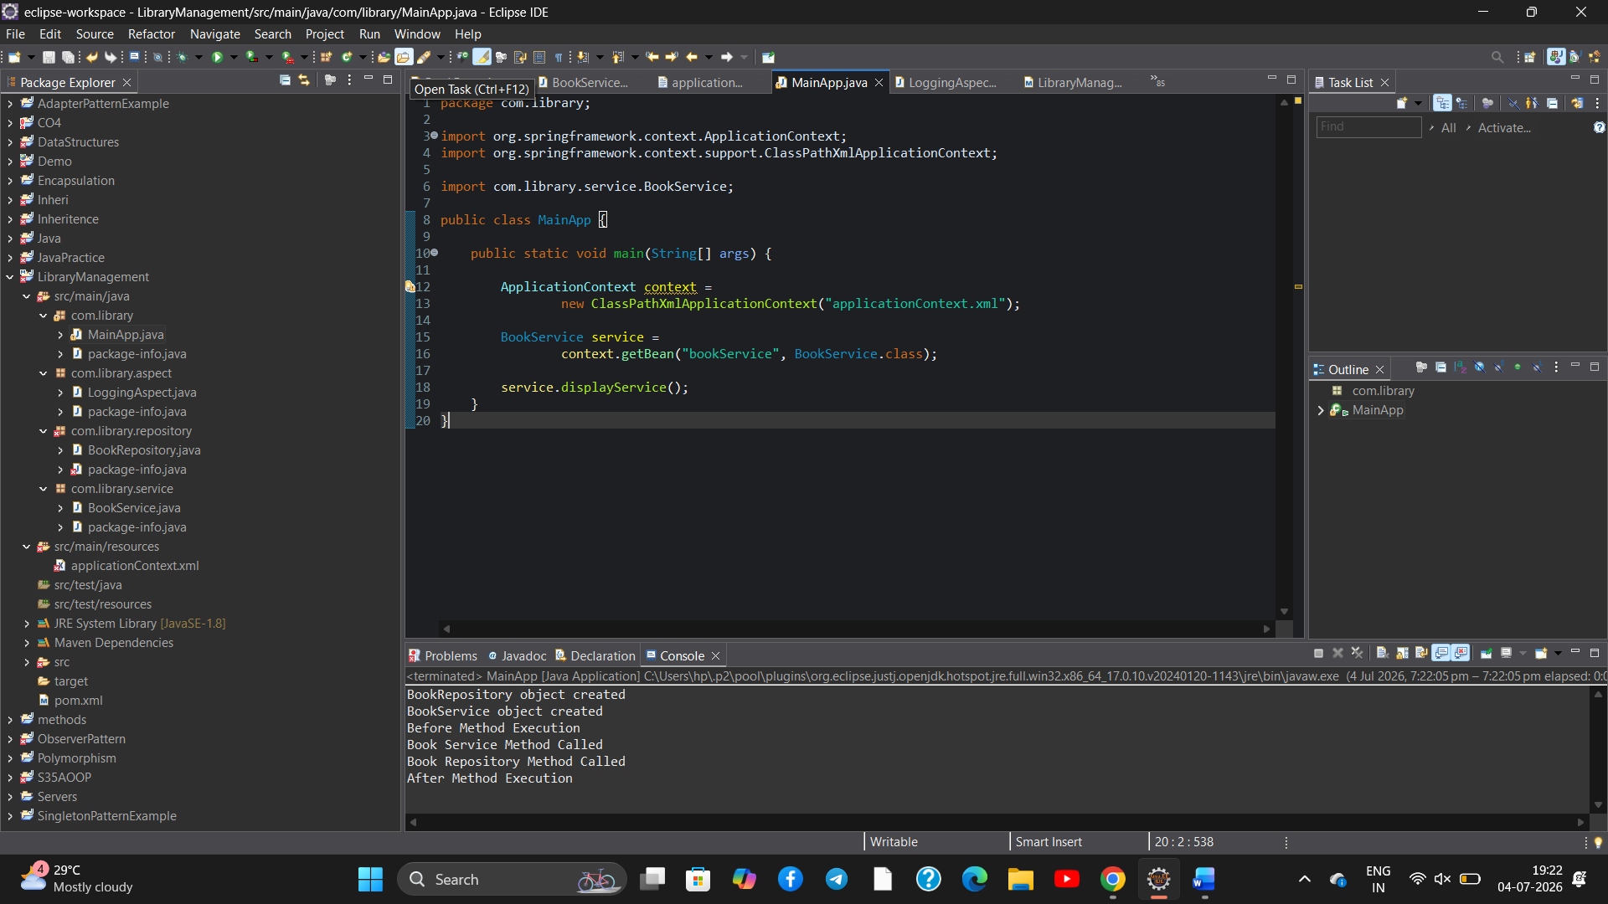
Conclusion :
- Successfully implemented basic Spring AOP.
- Used @Before and @After advice for logging.
- Verified logging before and after method execution.
- Successfully executed and tested the application

Exercise 4: Creating and Configuring a Maven Project
Aim:
To create and configure a Maven project by adding the required Spring dependencies and configuring the Maven Compiler Plugin.
Pom.xml:
<project xmlns="http://maven.apache.org/POM/4.0.0"
xmlns:xsi="http://www.w3.org/2001/XMLSchema-instance"
xsi:schemaLocation="http://maven.apache.org/POM/4.0.0
https://maven.apache.org/xsd/maven-4.0.0.xsd">
<modelVersion>4.0.0</modelVersion>
<groupId>com.library</groupId>
<artifactId>LibraryManagement</artifactId>
<version>0.0.1-SNAPSHOT</version>
<dependencies>
<!-- Spring Context -->
<dependency>
<groupId>org.springframework</groupId>
<artifactId>spring-context</artifactId>
<version>5.3.39</version>
</dependency>
<!-- Spring AOP -->
<dependency>
<groupId>org.springframework</groupId>
<artifactId>spring-aop</artifactId>
<version>5.3.39</version>
</dependency>
<!-- AspectJ Weaver -->
<dependency>
<groupId>org.aspectj</groupId>
<artifactId>aspectjweaver</artifactId>
<version>1.9.22.1</version>
</dependency>
<!-- Spring WebMVC -->
<dependency>
<groupId>org.springframework</groupId>
<artifactId>spring-webmvc</artifactId>
<version>5.3.39</version>
</dependency>
</dependencies>
<build>
<plugins>
<plugin>
<groupId>org.apache.maven.plugins</groupId>
<artifactId>maven-compiler-plugin</artifactId>
<version>3.11.0</version>
<configuration>
<source>1.8</source>
<target>1.8</target>
</configuration>
</plugin>
</plugins>
</build>
</project>
Output:
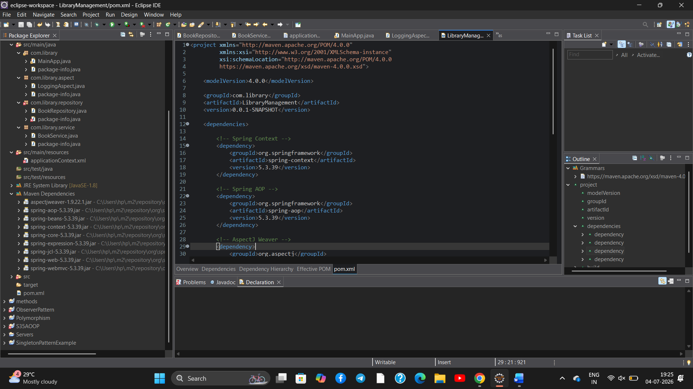
Conclusion:
- Successfully created and configured a Maven project.
- Added the required Spring dependencies.
- Configured the Maven Compiler Plugin.
- Verified successful Maven configuration.

Exercise 6: Configuring Beans with Annotations
instead of defining beans in XML, we use annotations.
Aim:
To configure Spring beans using annotations and component scanning instead of XML bean configuration.
Code:
1. pom.xml
<project xmlns="http://maven.apache.org/POM/4.0.0"
xmlns:xsi="http://www.w3.org/2001/XMLSchema-instance"
xsi:schemaLocation="http://maven.apache.org/POM/4.0.0
https://maven.apache.org/xsd/maven-4.0.0.xsd">
<modelVersion>4.0.0</modelVersion>
<groupId>com.library</groupId>
<artifactId>LibraryManagement</artifactId>
<version>0.0.1-SNAPSHOT</version>
<dependencies>
<!-- Spring Context -->
<dependency>
<groupId>org.springframework</groupId>
<artifactId>spring-context</artifactId>
<version>5.3.39</version>
</dependency>
</dependencies>
</project>
2. applicationContext.xml
<?xml version="1.0" encoding="UTF-8"?>
<beans xmlns="http://www.springframework.org/schema/beans"
xmlns:context="http://www.springframework.org/schema/context"
xmlns:xsi="http://www.w3.org/2001/XMLSchema-instance"
xsi:schemaLocation="
http://www.springframework.org/schema/beans
https://www.springframework.org/schema/beans/spring-beans.xsd
http://www.springframework.org/schema/context
https://www.springframework.org/schema/context/spring-context.xsd">
<!-- Enable Component Scanning -->
<context:component-scan base-package="com.library"/>
</beans>
3. BookRepository.java
package com.library.repository;
import org.springframework.stereotype.Repository;
@Repository
public class BookRepository {
public BookRepository() {
System.out.println("BookRepository object created");
}
public void displayRepository() {
System.out.println("Book Repository Method Called");
}
}
4. BookService.java
package com.library.service;
import org.springframework.beans.factory.annotation.Autowired;
import org.springframework.stereotype.Service;
import com.library.repository.BookRepository;
@Service
public class BookService {
@Autowired
private BookRepository bookRepository;
public BookService() {
System.out.println("BookService object created");
}
public void displayService() {
System.out.println("Book Service Method Called");
bookRepository.displayRepository();
}
}
5. MainApp.java
package com.library;
import org.springframework.context.ApplicationContext;
import org.springframework.context.support.ClassPathXmlApplicationContext;
import com.library.service.BookService;
public class MainApp {
public static void main(String[] args) {
ApplicationContext context =
new ClassPathXmlApplicationContext("applicationContext.xml");
BookService service =
context.getBean(BookService.class);
service.displayService();
}
}
Output:
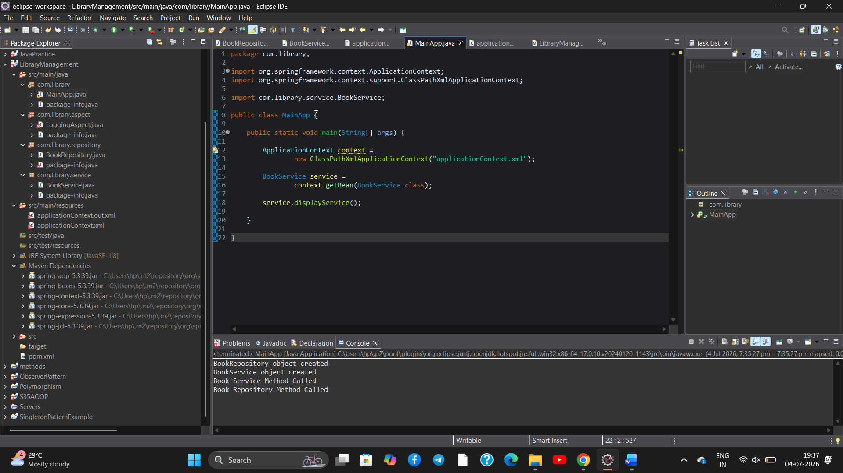
Conclusion:
- Successfully configured beans using annotations.
- Enabled component scanning in Spring.
- Implemented dependency injection using @Autowired.

Exercise 7: Implementing Constructor and Setter Injection
Aim:
To implement Constructor Injection and Setter Injection using the Spring Framework for dependency management in the Library Management application.
Code:
1. pom.xml
<project xmlns="http://maven.apache.org/POM/4.0.0"
xmlns:xsi="http://www.w3.org/2001/XMLSchema-instance"
xsi:schemaLocation="http://maven.apache.org/POM/4.0.0
https://maven.apache.org/xsd/maven-4.0.0.xsd">
<modelVersion>4.0.0</modelVersion>
<groupId>com.library</groupId>
<artifactId>LibraryManagement</artifactId>
<version>0.0.1-SNAPSHOT</version>
<dependencies>
<dependency>
<groupId>org.springframework</groupId>
<artifactId>spring-context</artifactId>
<version>5.3.39</version>
</dependency>
</dependencies>
</project>
2. applicationContext.xml
<?xml version="1.0" encoding="UTF-8"?>
<beans xmlns="http://www.springframework.org/schema/beans"
xmlns:xsi="http://www.w3.org/2001/XMLSchema-instance"
xsi:schemaLocation="
http://www.springframework.org/schema/beans
https://www.springframework.org/schema/beans/spring-beans.xsd">
<bean id="bookRepository"
class="com.library.repository.BookRepository"/>
<bean id="bookService"
class="com.library.service.BookService">
<!-- Constructor Injection -->
<constructor-arg ref="bookRepository"/>
<!-- Setter Injection -->
<property name="bookRepository"
ref="bookRepository"/>
</bean>
</beans>
3. BookRepository.java
package com.library.repository;
public class BookRepository {
public BookRepository() {
System.out.println("BookRepository object created");
}
public void displayRepository() {
System.out.println("Book Repository Method Called");
}
}
4. BookService.java
package com.library.service;
import com.library.repository.BookRepository;
public class BookService {
private BookRepository bookRepository;
// Constructor Injection
public BookService(BookRepository bookRepository) {
this.bookRepository = bookRepository;
System.out.println("BookService object created using Constructor Injection");
}
// Setter Injection
public void setBookRepository(BookRepository bookRepository) {
this.bookRepository = bookRepository;
System.out.println("Setter Injection completed");
}
public void displayService() {
System.out.println("Book Service Method Called");
bookRepository.displayRepository();
}
}
5. MainApp.java
package com.library;
import org.springframework.context.ApplicationContext;
import org.springframework.context.support.ClassPathXmlApplicationContext;
import com.library.service.BookService;
public class MainApp {
public static void main(String[] args) {
ApplicationContext context =
new ClassPathXmlApplicationContext("applicationContext.xml");
BookService service =
context.getBean("bookService", BookService.class);
service.displayService();
}
}
Output:
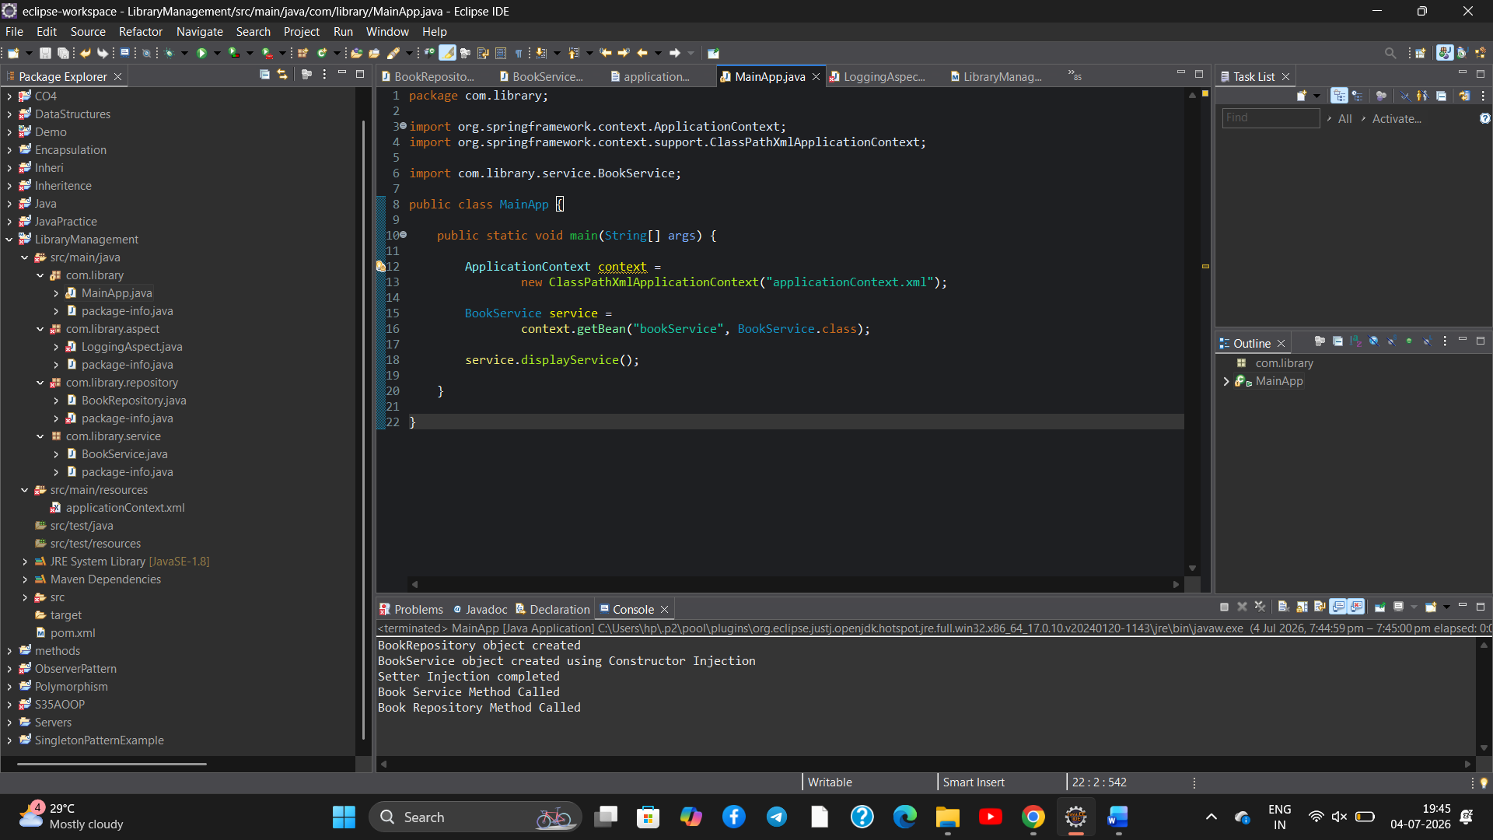
Conclusion:
- Successfully implemented Constructor and Setter Injection.
- Configured dependency injection using XML.
- Verified both injection methods.
- Successfully executed the application.

